Algebra 2 Midterm Exam
Name:
Directions: Use what you have learned in this course to answer the following questions. Justify your responses completely. Each question is worth 5 points.
1. Solve for n: –6(n – 8) = 4(12 – 5n) + 14n.
-6n +48= 48 -20n + 14n
6n+48 = 48-6n
-6n=-6n
N= all real numbers

2. For f(x) = 2|x+3| – 5, name the type of function and describe each of the three transformations from the parent function f(x) = |x|.
Vertical stretch = stretched
Vertical shift = 5 units down
Horizontal shift = 3 units left

3. Determine whether f(x) = –5$x^{2}$ – 10x + 6 has a maximum or a minimum value. Find that value and explain how you know.
F(X) = -5X²-10x+16
F(x) = -5(x²+2x)+6
F(x)= -5(x²+2x+1) +6+5
F(x)= 5(x+1) +11
Vertex is at (-1,11)
Vertex is the maximum y = 11

4. The median weekly earnings for American workers in 1990 was $412 and in 1999 it was $549. Calculate the average rate of change between 1990 and 1999.
Average rate of change = increase in money/increase in time
Average rate of change = (549- 412)/(1999-1990)
137/9

5. Find the roots of the parabola given by the following equation.

2x²+ 5x - 9 = 2x
2x²+3x-9
(2x-3) (x+3) = 0
X = 1.5
Or -3

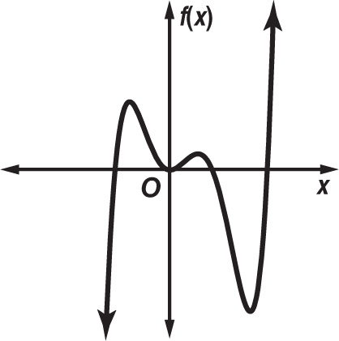
6. Describe the end behavior and determine whether the graph represents an odd-degree or an even-degree polynomial function. Then state the number of real zeros.
f(x)→+∞, as x→−∞
f(x)→+∞, as x→+∞
- It is odd- degree polynomial
- It intersect at 4 point therefore it has 4 real zeros

7. GEOMETRY Recall the formula for finding the area of a rectangle. Define a variable for the width and set up an equation to find the dimensions of a rectangle that has an area 144 square inches, given that the length is 10 inches longer than its width.
Let x = width
Let y = length
Area = xy =144in²
X(x+10)= 144
X²+10x -144 =0
(x-8) (x+18)=0
X = 8 or -18
We ignore -18 because it is negative

DIMENSIONS:
Length: 18in Width: 8in

8. The amount f(t) of a certain medicine, in milligrams, in a patient’s bloodstream t minutes after being taken is given by f(t) = $\frac{60t}{t^{2}+46}$ .
Find the amount of medicine in the blood after 20 minutes.
F(t) = 60t/(t²+46)
F(20) = (60x 20)/(20²+46)
1200/446
2.69mg

9. Graph f(x) = x² + 2x - 3, label the function’s x-intercepts, y-intercept and vertex with their coordinates. Also draw in and label the axis of symmetry.
X intercept = (1,0), (-3)
Y intercept = ( 0 ,-3)
Vertex = ( -1,-4)
The axis of symmetry x=1

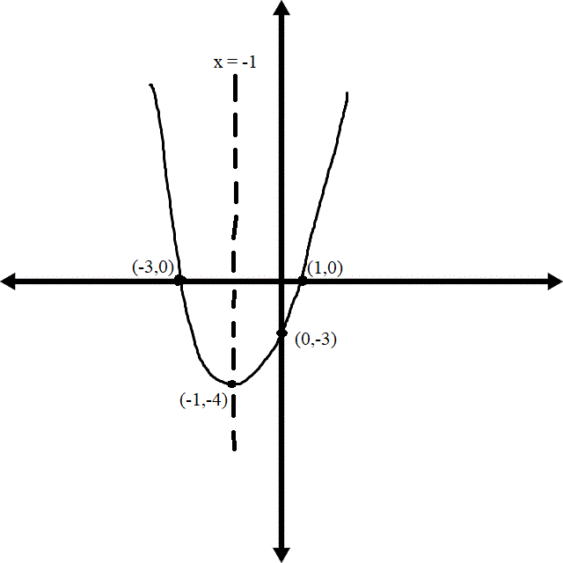

10. Determine whether the relation shown is a function. Explain how you know.
No it is not a function because it has two values of output at single input which is not possible in any function.
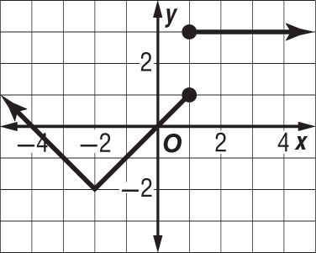
11. Solve the inequality and graph the solution on a number line.

–3(5y – 4) ≥ 17
5y-4≤-17/3
5y≤ -5/3
y≤-1/3

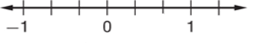

12. Assume that the wooden triangle shown is a right triangle.
​​
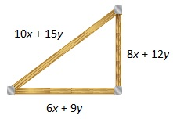
a. Write an equation using the Pythagorean Theorem and the measurements provided in the diagram.

Hint: (leg 1)² + (leg 2)² = (hypotenuse)²

(6x+9y)²+(8x+12y)²= (10x+15y)²

b. Transform each side of the equation to determine if it is an identity.

36x²+108xy+81y²+64x² +192xy +144y²= 100x²+300xy+225y²
100x²+300xy+225y²= 100x²+300xy+225y²
1=1

13. Use long division or synthetic division to find the quotient of $\frac{{2x}^{3} + x^{2} + 1 }{x + 1}$.
(2x³+x²+1)/(x+1)
2x²+ (-x²+1)/(x+1)
2x²-x + (x+1)/(x+1)
2x²-x+1

14. Simplify (9$k^{6}$ + 8$k^{4}$ – 6$k^{2}$)(4$k^{2}$ – 5).

4k²(9k⁶+8k⁴-6k²)- 5(9k⁶+8k⁴-6k²)
36k⁸+32k⁶-24k⁴-45k⁶-40+30k²
36k⁸-13k⁶-64k⁴+30k²

15. Find the inverse of h(x) = $\frac{2x + 6}{5}$.
(2x+6)/5
X= (2y+6)/5
5x-6=2y
Y=5x/2-3
h⁻¹(x)= 5x/2 -3

16. If f(x) = 2x – 1 and g(x) = $x^{2}$ – 2, find [g ◦ f](x).
[g * f](x).= g(x) * f(x)
[g * f](x)=(x²-2)(2x-1)
[g * f](x)= 2x³-x²4x+2

17. Graph the function y = $\sqrt{x + 4}$ – 2. Then state the domain and range of the function.
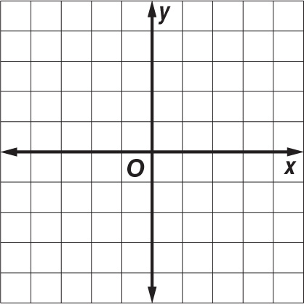

Domain:$[-4,∞)$

Range: $[-2,∞)$

18. If f(x) = 3x² – 2 and g(x) = 4x + 2, what is the value of (f + g)( 2) ?

(f+g)(x)= f(x) + g(x)
(f+g)(x) = 3x²-2 +4x+2
(f+g)(x)= 3x²+4x
(f+g)(2)= 12+8
20

The price of a sweatshirt at a local shop is twice the price of a pair of shorts. The price of a T-shirt at the shop is $4 less than the price of a pair of shorts. Brad purchased 3 sweatshirts, 2 pairs of shorts, and 5 T-shirts for a total cost of $136.

19. Let w represent the price of one sweatshirt, t represent the price of one T-shirt, and h represent the price of one pair of shorts. Write a system of three equations that represents the prices of the clothing.
Let w represent sweatshirt
T represent t-shirt
H represent shorts
W= 2h
T= h-4
3w+2h+5t=136

20. Solve the system. Find the cost of each item.
3(2h)+2h+5(h-4)= 136
13h-20=136
13h=156
H=156/12
H= 12
A Pair of short cost = 12$
A pair of sweatshirt cost 24$
Price of T- shirt cost 8$

